**Application Process on Confucius Institute Scholarship website （**[**http://cis.chinese.cn/account/login**](http://cis.chinese.cn/account/login)**）**

**The 1st step: Create an account and password with your usual email.**

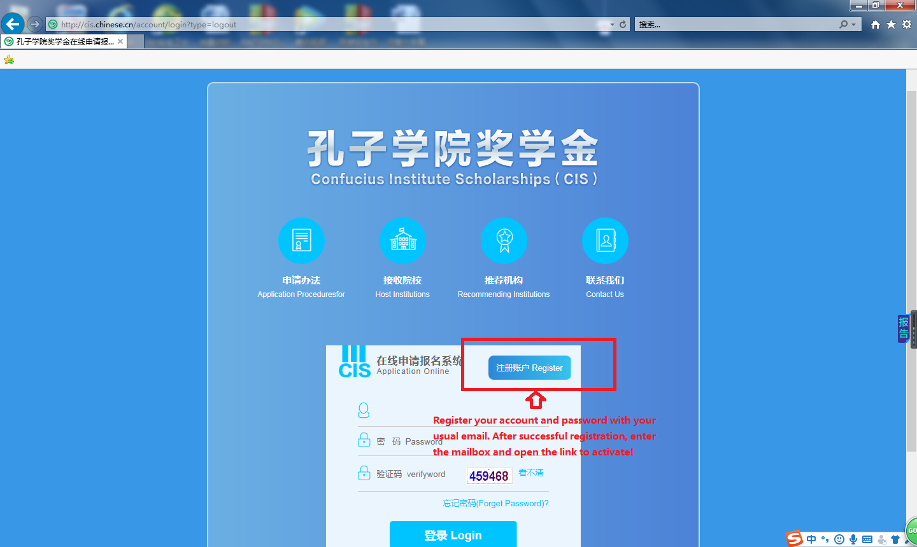

**The 2nd step: please read the Recruitment and illustrate carefully, complete the application Form and upload your scanned documents.**

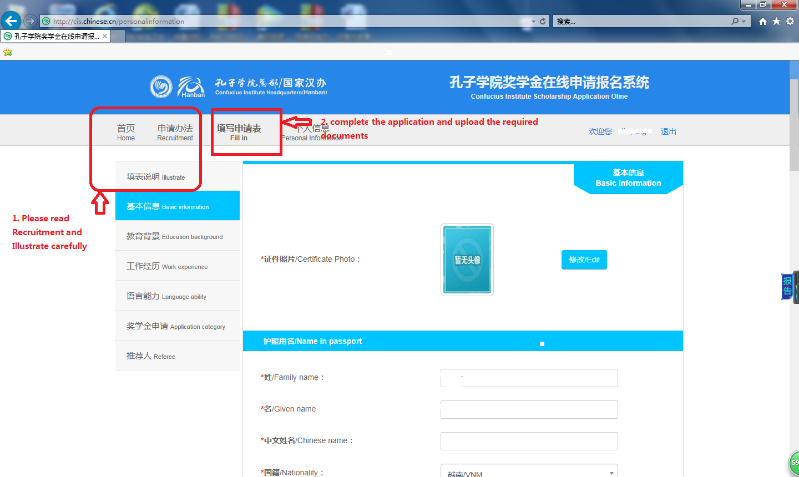

**The 3rd step: Confirm your application information and your documents in right place, click “submit”, and finish your application.**

