Application Process on Confucius Institute Scholarship website （http://cis.chinese.cn/account/login）
The 1st step: Create an account and password with your usual email.
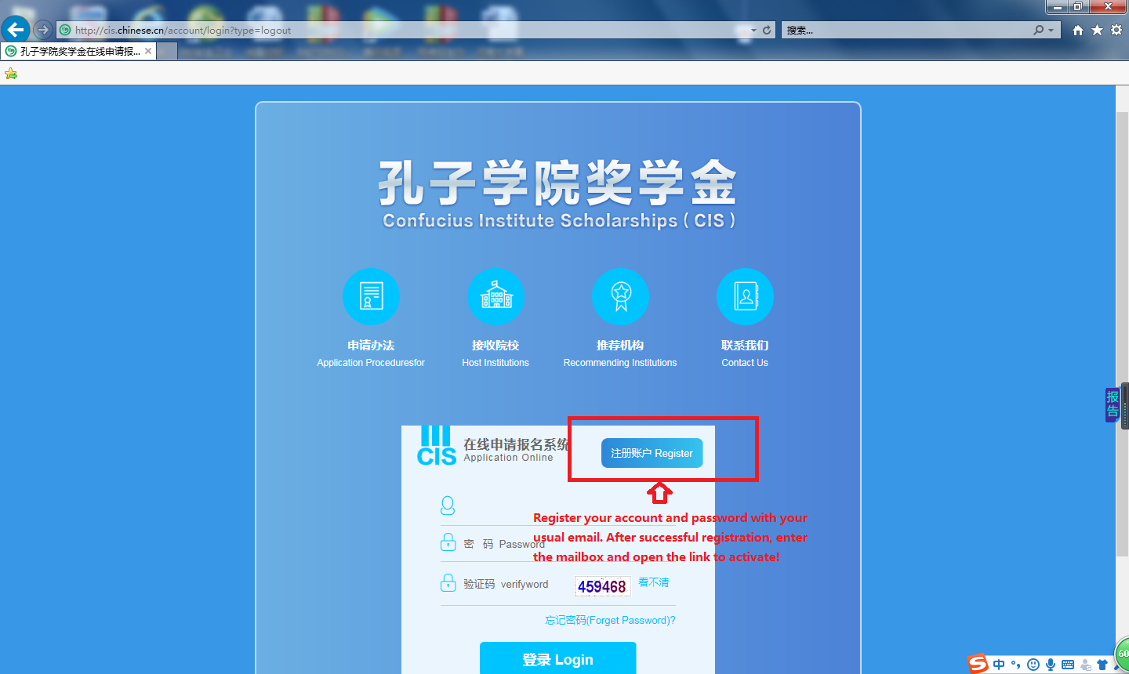

The 2nd step: please read the Recruitment and illustrate carefully, complete the application Form and upload your scanned documents.
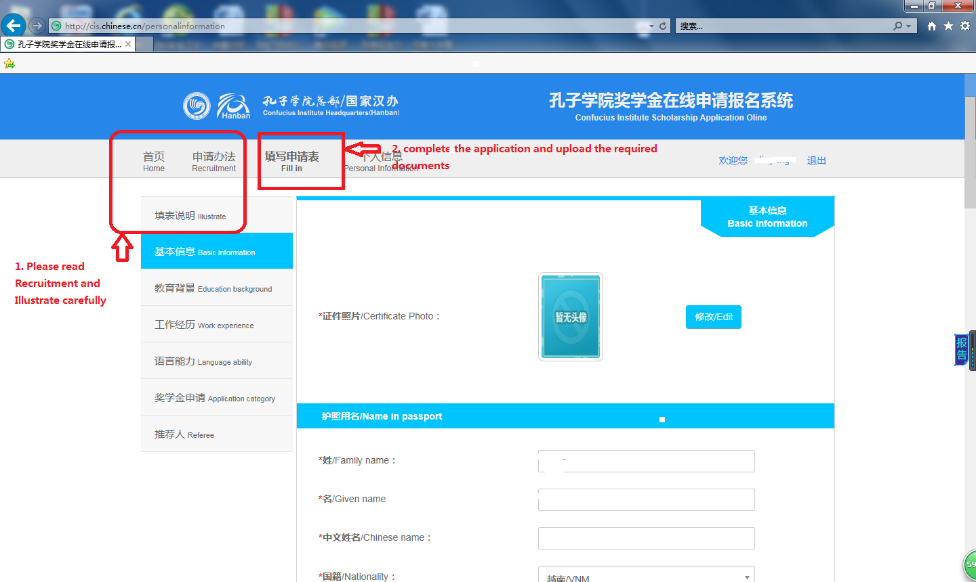
The 3rd step: Confirm your application information and your documents in right place, click “submit”, and finish your application.
