Ⅳ. Introduction of the PhD project “Mechanical Engineering”
Manufacturing is the foundation of modern industry, and its development requires a large number of high-level application talents. The small number of key universities in Henan Province has led to the lack of local high-level talents to meet the development of the manufacturing industry, and the development sustainability of key industries with strong driving effects such as equipment manufacturing, new materials, and logistics equipment in Henan Province is not strong due to the lack of corresponding talent support.
After long-term development, the degree point has formed four stable research directions and obvious characteristics and advantages of material molding and mold, grain and oil machinery automation, intelligent logistics equipment and special vehicles, and intelligent manufacturing of construction machinery. In recent years, the teachers in this project have successfully got more than 27 projects granted by National Natural Science Foundation of China, and presided over 10 formulation of national norms and industry standards, More than 30 authorized invention patents. They also have won 1 second prize of national scientific and technological progress, 17 provincial and ministerial science and technology awards, and 10 provincial teaching achievement awards. This discipline has ranked the top 1% of the world Engineering ESI ranking, accumulating rich experience in running schools and running conditions, laying a solid foundation for this application point.
The discipline has established a complete postgraduate training system, and more than 30 domestic enterprises such as COFCO Group, China Grain Storage Group, Zhengzhou Machinery Research Institute, Zhengzhou Coal Machinery, Henan Far East Drive Shaft, Weihua Group and other domestic enterprises have jointly built industry-university-research cooperation and internship bases, jointly carried out technical research, established the engineering practice platform and training base required for postgraduate training, and formed a distinct training model of industry-education integration and collaborative education. In the process of talent training, the school has always adhered to the basic task of educating people, cumulatively trained more than 300 academic and professional degree master's degree students, 22 doctoral students, relying on the special needs of the country doctoral talent project to train 9 doctoral students, one-time employment rate of more than 98%, the quality of training has been recognized by society.
The discipline has national engineering research centers for wheat and corn deep processing, engineering research centers for grain storage and safety of the Ministry of Education, key laboratories of grain information processing and control of the Ministry of Education, Henan Province Key Laboratory of Superabrasive Grinding Equipment, key laboratories of grain optoelectronic detection and control in Henan Province, Intelligent Logistics Equipment and Vehicle Engineering Technology Research Center of Henan Province, Engineering Laboratory of Automotive Composite Materials in Henan Province, and Henan Provincial Engineering Laboratory of Food Internet of Things Technology. It has a national experimental teaching demonstration center, a experimental teaching demonstration center, a national talent training model innovation experimental zone, and a graduate education innovation training base in Henan Province. There are 2665 sets of various teaching and scientific research instruments and equipment, and the total asset value of the instruments is more than 45.6 million yuan. In addition, leading enterprises as Zhengzhou Wangu Machinery Co., Ltd., Zhongyuan Neibei Group Co., Ltd., Yutong Heavy Industry Co., Ltd. and other related fields have built off-campus talent training bases to meet the needs of professional training.
The discipline and Weihua Group, Foguang Power Generation and other enterprises have long-term close projects and personnel cooperation, relying on its key laboratory of lifting logistics equipment, on-board power supply comprehensive integration and measurement and control technology national and local joint engineering laboratory, Henan Provincial Engineering Laboratory for power supply vehicle equipment and other state key laboratories for scientific research and graduate training. Relying on the National Grain Processing Equipment Engineering Technology Research Center established by Kaifeng Maosheng Machinery Co., Ltd., Yihe Precision Industry Holding Co., Ltd. and more than 20 enterprises have established postgraduate innovation training bases, providing a broader platform for the training of postgraduate students.
The standard study years for PhD students are 3 years. The maximum study time is not more than 5 years.
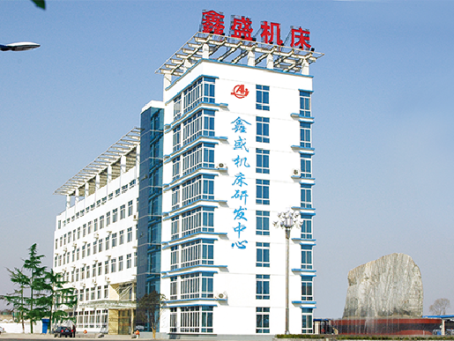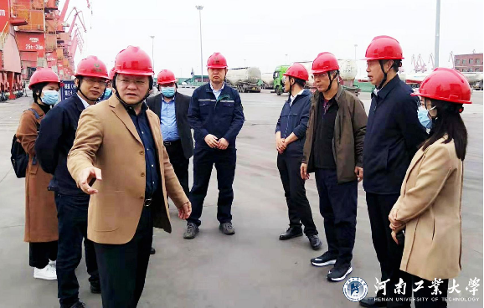
Joint development of Inspection the northeast comprehensive
“12m CNC Thread Grinding Machine” industrial base for grain storage
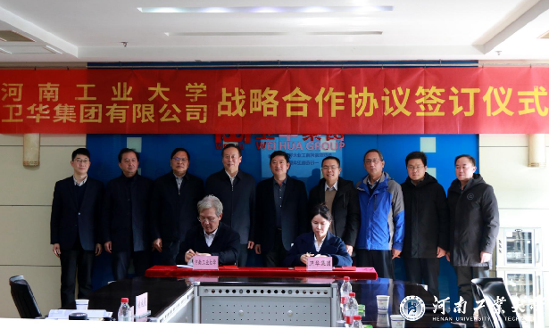
Signing ceremony of strategic cooperation between
Henan University of Technology and Weihua Group

