Ⅱ. Introduction of the Undergraduate Projects
2.1 Mechanical Design, Manufacturing and Automation
(Bachelor of Engineering, 4-year undergraduate)
Mechanical Design, Manufacturing and Automation major is one of the earliest majors founded in our school, and has a history of 60 years. This major was rated as a characteristic major of Henan Province in 2007, and became the first batch of pilot majors of comprehensive professional reform in Henan Province in 2012, and was designated as a “Youpei Engineering” major by the school, passed the professional certification of China Engineering Education in 2017, and was recognized in December 2019 Monthly, it was selected as one of the first batch of national first-class undergraduate majors. At present, there is 1 provincial mechanical engineering experimental teaching demonstration center, 1 provincial excellent teaching team, and 2 provincial excellent courses. Since 2009, the teachers have won 3 first prizes and 2 second prizes for teaching achievements in Henan Province. Student scientific and technological innovation activities are widely carried out, and the last two national college students mechanical innovation design competitions have repeatedly won good results. There are 9 professors, 17 associate professors, 2 doctoral supervisors and 11 graduate supervisors.
This major mainly cultivates modern manufacturing engineering and mechanical and electronic senior engineering and technical personnel and management talents who have the basic theory and engineering application ability of mechanical product design, manufacturing, scientific research, operation management, etc., and can carry out design, manufacturing, scientific research, operation management and other work in the field of mechanical design and manufacturing. After graduation, you can engage in general mechanical design and manufacturing, intelligent manufacturing, electromechanical and electronic engineering, mechanical CAD/CAM integrated manufacturing, numerical control, electrical control, rapid prototyping, special processing and other related work. The main jobs are mechanical engineers, mechanical designers, technical support engineers, market development engineers, sales engineers, equipment engineers, process engineers, etc. The demand for this professional talent is strong, and the employment rate has remained 100% year after year.
In recent years, Teachers of this major are responsible for more than 20 major national science and technology projects、863 project and national Natural Science Foundation of China and other national projects, and have got more than 10 provincial and ministerial science and technology awards.
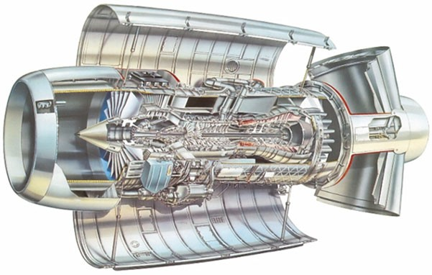
Nonparametric dynamics of uncertain rotor systems

2.2 Intelligent Manufacturing Engineering
(Bachelor of Engineering, 4-year undergraduate)
The intelligent manufacturing engineering major is based on the national and regional economic and technological development and the upgrading of the machinery industry structure, in response to the “Made in China 2025” strategy, the new engineering major approved by the Ministry of Education in 2018 begin to enroll students in 2020. This major has won 1 national first-class undergraduate course, 1 first-class undergraduate course in Henan Province, 2 first prizes for teaching achievements in higher education in Henan Province, 2 second prizes for scientific and technological progress in Henan Province, approved to build a famous teaching studio for colleges and universities in Henan Province, and undertake more than 20 various scientific research projects.
This major cultivates composite engineering and technical talents with basic theories of natural sciences and mechanical, electrical, information and other related professional knowledge, systematic mastery of basic theories and basic skills in intelligent manufacturing engineering and related fields, especially key technologies such as intelligent manufacturing technology and equipment, digital design and manufacturing, intelligent production management and intelligent manufacturing systems, and the ability to engage in the planning and design of intelligent manufacturing technologies and systems, scientific research, etc. This major is characterized by the intersection of disciplines, involving mechanical engineering, control engineering, electronic technology, computer networks, management engineering, embedded technology and artificial intelligence technology, etc. The college focuses on industrial robots, digital design and numerical control technology according to its own educational resources.
There are 13 full-time teachers in this major, including 2 professors, 6 associate professors, 10 doctors, 1 doctoral supervisor, 7 master's supervisors, and 1 famous teacher in Henan Province. “Yongyou-HAUT” Smart Factory Experimental Platform, Intelligent Vision Detection Laboratory, Industrial Internet of Things Laboratory and other professional laboratories.
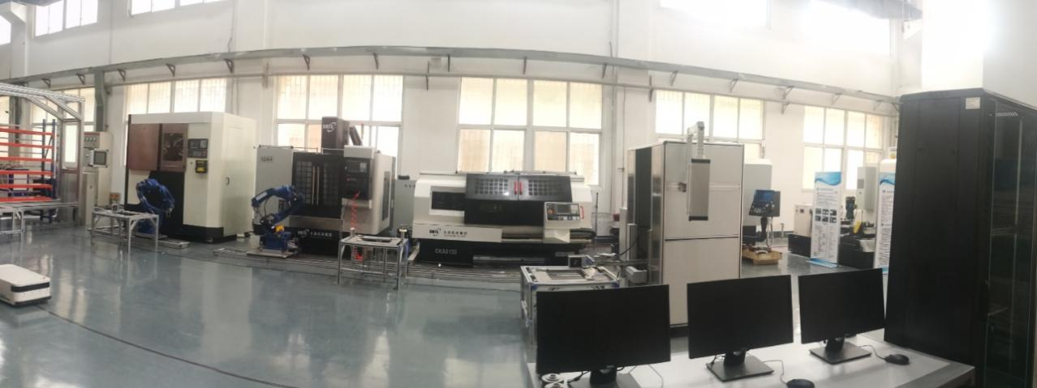
Intelligent factory experimental platform

2.3 Process Equipment and Control Engineering
(Bachelor of Engineering, 4-year undergraduate)
The process equipment and control engineering major originated from the “granary machinery class” opened by the Central Grain Cadre School in 1956, focusing on the professional teaching engineering research, design and development of grain and oil processing equipment. In 2003, it was renamed as “Process Equipment and Control Engineering (Grain and Oil Engineering Equipment)”, and in 2013, it began to enroll students, successfully passed the Certification of China's Engineering Education Major in 2018, and was selected as a national first-class undergraduate major in 2020. This major is a characteristic major of Henan Province, enjoys a high reputation in the national grain and oil industry, and is the only mechanical major in the national grain industry with a three-level talent training system of bachelor's, master's and doctoral degrees.
This major mainly cultivates senior engineering and technical personnel and management talents who have the basic knowledge of natural sciences required in the field of mechanical engineering and grain, the basic theory of engineering technology, and the design, manufacturing and automatic control of grain industry process equipment, and can cooperate with the team to engage in new product development, design and manufacturing, production management, sales and after-sales service of grain and oil engineering process equipment in the grain industry. So far, more than 4,000 graduates have been trained for the country. Among them, more than 20% graduates are admitted to graduate students of well-known universities at domestic and abroad, and the rest of the graduates are mostly employed in well-known domestic enterprises such as the Provincial and Municipal Grain Reserve Management Company, COFCO Group, the National Academy of Grain Sciences, and Jiangsu Fengshang Company. Graduates are well received by the community and are well-known in the national grain industry and other related industries, with an employment rate of 100% in the past three years.
There are 7 professors, 12 associate professors, 11 doctors, 3 doctoral supervisors, 8 graduate supervisors, 1 national outstanding teacher, and a teaching team in Henan Province. In recent years, the teachers have undertaken more than 60 scientific research projects such as the National Science and Technology Support Program, the National Key Research and Development Program, and the Key Scientific and Technological Research Projects of Henan Province. They have won 1 national science and technology progress award and more than 10 provincial and ministerial science and technology progress awards. It has formulated more than 30 national and industry standards, obtained more than 30 national invention patents, and published more than 210 papers.
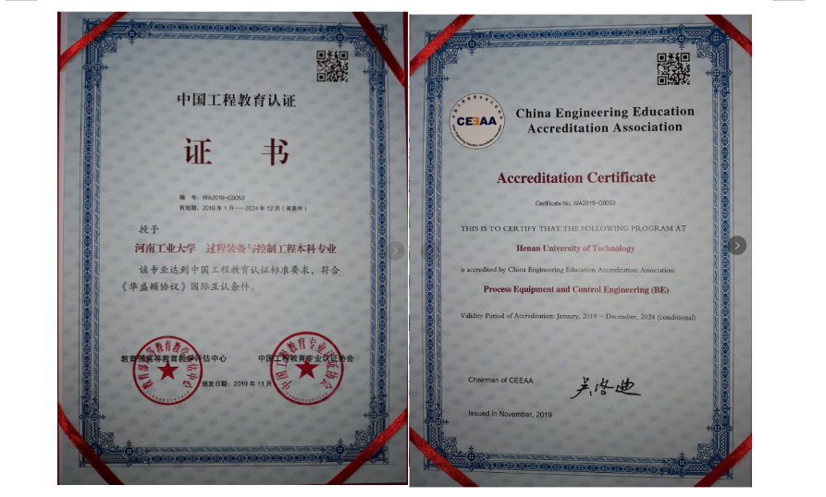
The major of Process Equipment and Control Engineering has passed the Professional certification of China Engineering Education
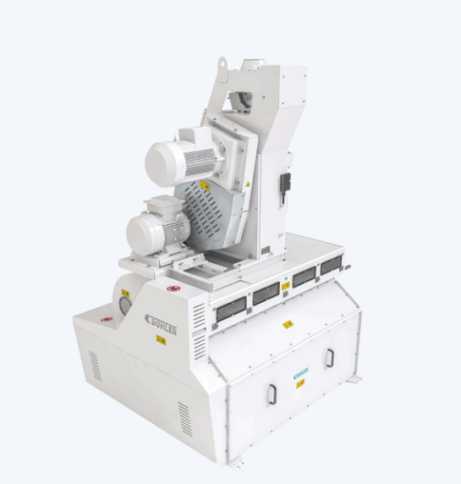
Professor Ruan Jinglan and Wuxi Buller Machinery company jointly developed the automatic separator

2.4 Materials Forming and Control Engineering
(Bachelor of Engineering, 4-year undergraduate)
The major of materials forming and control engineering has a history of more than 30 years, and was rated as a national demonstration major in 2000, and a first-class undergraduate major in Henan Province in 2020, and the characteristic direction of this major is mold design and manufacturing and welding technology and its automation. Students have an excellent learning style and rich and colorful scientific and technological innovation practice activities. In the past three years, 6 students in this major have participated in the Challenge Cup Extracurricular Academic Science and Technology Works Competition for College Students, and more than 30 students have participated in various scientific and technological innovation competitions such as the National Composite Materials Bridge Competition, the Composite Material Design Competition, and the Metallographic Skills Competition, and achieved excellent results.
This major mainly cultivates senior engineering and technical personnel and management talents who have the basic theory and technology of materials forming and processing, and can engage in design and manufacturing, technology development, scientific research and production management in the fields of metal and non-metallic materials forming technology, mold design and manufacturing, metal welding technology and welding automation, etc., and develop morally, intellectually and physically. After graduation, you can engage in mold design and manufacturing, welding technology, welding automation, new materials research and development, as well as management, quality inspection and supervision in related fields. The social demand of this major is large, the employment prospects are good, and the employment rate of graduates in the past three years has reached 100%, and the examination and research rate is about 35%. The professional teaching conditions are perfect, and there are teaching laboratories such as welding laboratories, metallographic laboratories, heat treatment laboratories, materials performance laboratories, joint research and development centers with enterprises, which provide a strong guarantee for cultivating students’ innovative practice ability.
There are 3 professors, 12 associate professors, 14 doctors, 2 doctoral supervisors, 6 graduate supervisors, and 1 famous teaching teacher in this major. The teaching results are fruitful, and a number of outstanding academic achievements have been made in the direction of materials processing technology, materials characteristics, manufacturing technology, special functional materials, etc., and in recent years, the teachers in this major have won 2 major national science and technology special projects, 12 national natural science foundations, and undertaken 50 various scientific research projects.
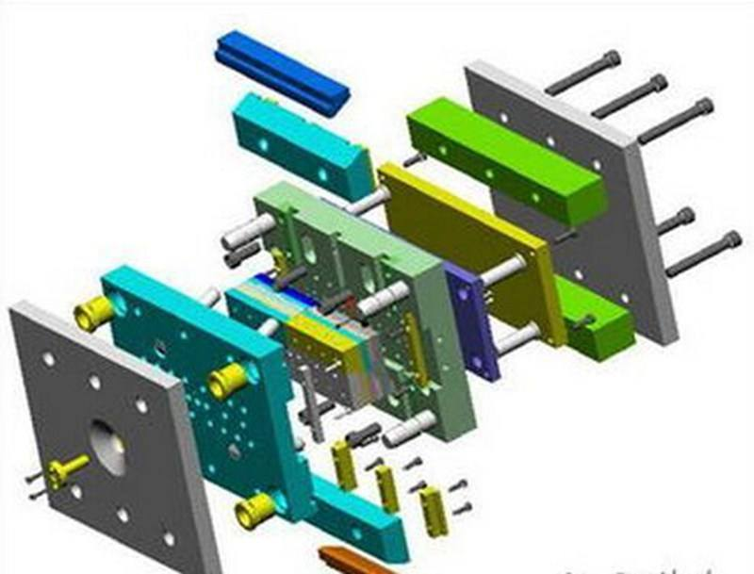
Mold design and manufacturing process

2.5 Vehicle Engineering
(Bachelor of Engineering, 4-year undergraduate)
The Department of Vehicle Engineering was established in 1996 and has a history of more than 20 years. After years of accumulation of experience in running schools, this major has formed a “one-special two-way” training model dominated by intelligent networked vehicle technology and supported by modern automobile design theories and methods.
This major cultivates engineering and technical talents who have basic theoretical knowledge and application ability of vehicle engineering majors, and can engage in design, manufacturing, scientific and technological development and application research, vehicle production management, vehicle testing and maintenance, vehicle marketing, vehicle safety and evaluation in the field of vehicle engineering, management and marketing talents. After graduation, students can engage in vehicle engineering design and manufacturing, experimental research, technology development, operation management, quality inspection and supervision, vehicle marketing, vehicle safety and evaluation, insurance claims, automobile teaching and other work. Students in this major have excellent theoretical knowledge, and in recent years, they have won many awards in the National College Students Mechanical Innovation Design Competition, the National College Students Mathematical Modeling Competition, and the Intelligent Automobile Competition. In the past three years, the admission rate of graduate school has reached to more than 35%, many people have guaranteed or been admitted to domestic double-first-class universities for graduate school, and some students have been admitted to well-known foreign universities. The employment rate of graduates is 100%, mainly distributed in SAIC Passenger Vehicles, Yutong Bus, Zhengzhou Haima Automobile, GreatWall Motor, Chery Automobile and other well-known automobiles, parts and innovative high-tech enterprises.
There are 8 deputy senior professional titles of deputy senior or above, 7 doctors, 5 graduate supervisors, and the proportion of double-teacher teachers with enterprise experience in the teaching team has reached to 40%.
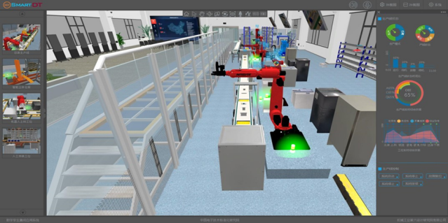
Development of digital twin technology of intelligent logistics equipment for intelligent factory

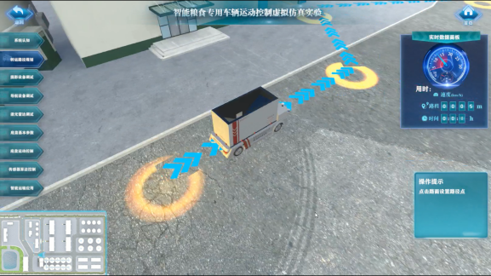
Development and virtual simulation experiment of intelligent grain logistics platform vehicle based on “5G⁺ autonomous driving technology” for smart grain depot

