国际学生个人简历CV
姓/ Family Name |  |  | YOUR FAMILY NAME |  |  |  |  |  |  | 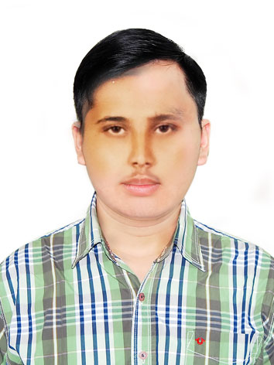
名/ Given Name |  |  | YOUR GIVEN NAME
中文姓名/Chinese Name |  |  |  |  | 国籍/Nationality |  |  | Country
出生日期/Date of Birth |  |  | 2000-01-01 |  | 性别/Gender |  |  | Female/Male
母语/Native Language |  |  | French |  | 宗教/Religion |  |  | Christian
婚否/Marital Status |  |  | Single |  | 护照号/Passport No. |  |  |  | AB123456
联系方式/ Contact Information
本人电话/Tel. No. |  |  | +1234567890 |  |  | 电子邮箱/E-mail |  |  | Youname@outlook.com
紧急联系人/Emergency Contact Person’ Name |  |  | Sudden |  |  | 紧急联系人电话/ Emergency Tel. |  |  | 13912345678
学习及工作经历（从小学到现在）
Education and work background （from primary school to present）
时间/Years and Months |  | 机构/工作职位  Institutions/ Work Position |  |  |  |  | 机构名称/Institutions Name
2013.08-2016.07 |  | 小学/ Primary school |  |  |  |  | Your Primary School Name
2016.08-2017.07 |  | 初中/ Middle school |  |  |  |  | Your Middle School Name
2017.08-2019.07 |  | 高中/ High school |  |  |  |  | Your High School Name
2019.08-2020.02 |  | 大学/ University/College |  |  |  |  | Abc University/Def College
2019.08-2020.02 |  | 研究生/ University/College |  |  |  |  | Abc University/Def College
2019.08-2020.02 |  | 语言学习/Language study |  |  |  |  | Language Study Institute
2019.08-2020.02 |  | 教师/ Teacher |  |  |  |  | The Institute You Work For
2019.08-2020.02 |  | 自学/Self study
2019.08-2020.02 |  | 访学/Visiting scholar |  |  |  |  | Abcdef University
家庭成员信息/Family Members
关系/Relation | 姓名/Name |  |  | 职业/Occupation |  |  |  | 联系电话和邮箱/Tel/E-mail
父亲/Father | Father’s Name |  |  | United Nations |  |  |  | +123456789012
母亲/Mother | Mother’s Name |  |  | United Nations |  |  |  | +123456789012
其它自我情况介绍
Other Information(Hobby/ Honor and Award)
I have many hobbies like reading, playing sports, and listening music. Furthermore, I have from at University, the University of Modern Sciences, I have participate in many useful training courses like Towards better performance of Writing and .
In 2010, I became a member in team of International Union of in .
In 2018, I have been .

