广东外语外贸大学 留学生教育学院
2027春季国际学生·学历生报名通知
Institute for International Education, Guangdong University of Foreign Studies
Notice on Degree Programs Application for International Students
Spring Enrollment, 2027

- 报名时间：
Application Period:
2026年9月30日— 12月10日。*如实际报名时间有变动，请以留学生院通知为准。
Application Period: From September 30 to December 10, 2026. *Any change in the actual application time, please refer to the further notice of the Institute for International Education.

二、报名方式：
How to apply:
网上报名。请登陆http://gdufs.17gz.org/ 注册报名。报名后必须与留院招生办电话（0086-20-36207141、36207142）或邮件（studyiniie@gdufs.edu.cn）确认。
Online application. Applicants please submit online application through http://gdufs.17gz.org/ and please get confirmation via phone call (0086-20-36207141, 36207142) or Email (studyiniie@gdufs.edu.cn) to the Admission Office, Institute for International Education (IIE).

三、申请条件：
Eligibility:
1、不具有中国国籍，持有外国护照并符合《教外函〔2020〕12号》的相关要求。
2、身心健康，符合中国政府规定的、达到办理来华学习签证或居留证件的体检标准。
3、对华友好，遵守中国法律法规及校纪校规，勤奋好学，成绩优秀，品行端正；无违反校规校纪行为的记录，无治安处罚，无犯罪记录。
4、学历、学业水平、语言水平及CSCA成绩达到所申请专业的要求。
5、申请攻读学士学位者，年龄一般不超过30周岁；申请攻读硕士学位者，年龄一般不超过35周岁；申请攻读博士学位者，年龄一般不超过40周岁。
6、遵守其他相关法律法规要求的事项。
To be eligible, an applicant must:
- Be non-Chinese nationality, hold a foreign passport and meet the relevant requirements of the Regulation No.〔2020〕12 by Ministry of Education of the People’s Republic of China.
- Stay in good health both mentally and physically, and meet the physical examination standards for the study visa or residence permit in China required by the Chinese government.
- Abide by Chinese laws and regulations and the University rules and regulations; be diligent and well-performed in academics and good conduct; no violation of the University rules and disciplines, no public security punishment, no criminal record.
- The educational background, academic performance, language proficiency, and CSCA scores must meet the requirements for the program to which they are applying..
- Under the age of 30 for the undergraduate programs, under the age of 35 for the postgraduate programs and under the age of 40 for the doctoral programs in principle.
- Abide by requirements of other relevant laws and regulations.

四、招生项目及材料要求：
Degree Programs and Documentation Requirements:
本科项目：
留学生教育学院汉语言、汉语言（商务汉语）本科专业：https://iie.gdufs.edu.cn/info/1078/3350.htm。
Undergraduate Programs:
Chinese B. A program and Chinese (Business Chinese) program especially for international students by IIE: https://iie-en.gdufs.edu.cn/info/1132/2191.htm .

网上报名所需材料：
- 高中毕业证书及高中毕业成绩单扫描件（非中文或英文的，须提供经公证的中文或英文文本）。
- 来华留学本科入学学业水平测试（CSCA）成绩报告。考试科目：
招生本科专业 | 授课语 | 考试科目
汉语言类，翻译及外国语言类，经贸类，管理学类，法学类，教育学类，新闻类，艺术类等专业等 | 汉 语 | 数学 + 文科中文
计算机科学与技术，应用心理学 | 汉 语 | 数学 + 理科中文  + 物理或化学
国际商务（全英教学） | 英 语 | 数学
注：
- 数学为必考基础科目。所有申请我校本科专业的来华留学生必须要考数学科目。可根据所选专业的授课语言选择中文试卷或英文试卷。
- 申请汉语授课本科项目者，请务必参加专业中文考试卷（文科中文或理科中文）；申请汉语言本科项目，如提交自考试日期起2年内有效的HSK4级180分（含）或以上成绩，可免考文科中文。
- CSCA成绩提交时间：春季入学，每年1月初前；秋季入学，每年6月底前。具体考试时间及场次安排请见CSCA官网：https://csca.cn/home。更详细的考试说明与考试大纲请见CSCA官方网站：https://csca.cn/testprep/examsv。如有问题，请与广东外语外贸大学留学生教育学院招生办公室联系。
3、中文授课专业：须提供HSK5级180分或以上证书扫描件，以及：
（1）参加必要的入学考试，主要形式为：笔试+面试，或面试。
（2）汉语言专业本科: 申请汉语言本科一年级暂无需提供HSK证书，但须有相当于HSK3级的汉语水平；插班汉语言本科二年级须提供HSK4级180分或以上证书；插班汉语言（商务汉语）本科三年级须提供HSK5级180分或以上证书。
4、英文授课专业：须有托福70分或雅思5.5分以上语言水平证书，以及：
（1）参加必要的入学考试，主要形式为：笔试+面试，或面试。
（2）未能提供托福雅思者，须通过学院组织的入学考试，考试形式为：笔试+面试。以英语为官方语言国家的申请人可免考笔试，但仍需面试。
（3）申请英文授课专业，入学时不要求有汉语水及HSK成绩，但要求毕业前必须通过HSK4级水平考试。
5、证照：护照个人首页，*来华签证页（如有）扫描件，一寸免冠证件彩照。
6、在有效期内的身体检查报告。
7、大学另有通知需补充的材料，如推荐信、无犯罪记录证明等。请参考《附录3.广东外语外贸大学关于其他补充材料的说明》。

Documents required for online application:
1. High school certificate and transcript. The notarized Chinese or English version must be provided if the originals are in other languages.
2. Test results of the China Scholastic Competency Assessment (CSCA). Required Subjects:
Undergraduate Programs Offered | Language of instruction | Examination Subjects
Chinese, Translation and Foreign Languages, International Trade and Economics, Management Studies, Law, Education, Journalism, Arts, and other related disciplines. | Chinese | Mathematics & Humanities Chinese
Computer Science and Technology, Applied Psychology | Chinese | Mathematics &  STEM Chinese & Physics (or Chemistry)
International Business(English-taught) | English | Mathematics
Note:
- Mathematics is a compulsory foundational subject. All international students applying for undergraduate programs at our university must sit the Mathematics examination. Applicants may select either the Chinese-language or English-language examination paper based on the language of instruction for their chosen programs.
- Applicants for Chinese-taught undergraduate programs must sit the CSCA test in Chinese (either Humanities Chinese or STEM Chinese). Applicants for undergraduate programs in Chinese majors may be exempted from the Humanities Chinese exam if they submit a valid HSK Level 4 score of 180 points or above, obtained within two years prior to the examination date.
3. CSCA results submission deadlines: for Spring Intake: by early January each year; for Autumn Intake: by late June each year. For specific examination dates and session arrangements, please refer to the CSCA official website: https://csca.cn/home. For detailed examination guidelines and syllabuses, please check the CSCA official website: https://csca.cn/testprep/examsv. If have any queries, please do not hesitate to contact the Admissions Office of the Institute for International Education, GDUFS.
- Chinese-taught Programs: Photocopy of HSK Level 5 certificate with 180 points or above, and in additional：
- Take the necessary entrance examination, mainly in the form of: written test + interview, or interview only.
- Chinese B.A programs: applicants for the 1st year of the Chinese B.A programs are not required to submit an HSK certificate when applying, but must have a Chinese language proficiency equivalent to HSK Level 3; simultaneously, those seeking entry into the 2nd year must provide an HSK Level 4 score of 180 points or above, and applicants for 3rd year Chinese(Business Chinese) must provide an HSK Level 5 score of 180 points or above .
- English-taught Programs: Applicants must hold a TOEFL score of 70 or an IELTS score of 5.5 or above, and in additional：
- Take the necessary entrance examination, mainly in the form of: written test + interview, or interview only.
- Those who fail to provide TOEFL or IELTS certificates must pass the entrance examination organized by the institute in the format of written exam and interview. Applicants from English-speaking countries can be exempted from the written examination, but are still required to attend an interview.
- For applications to English-taught programs, Chinese language proficiency and HSK is not mandatory, but it is required that the HSK Level 4 exam be passed prior to graduation.
- Photocopy of passport main page and Chinese visa page (*if any), and a 1-inch digital bareheaded colorized photo.
- Valid medical examination report.
- Any additional materials required by the University as per separate notifications, such as recommendation letter, Non-Criminal Record Certificate and ect. Please refer to Appendix 3. [GDUFS] Notice on Other Supplementary Materials.

五、录取：
Admission：
录取结果预计于2027 年1月中下旬陆续发放。请注意：网上报名系统中所显示的录取结果仅代表大学初审意见或拟录取意愿，最终录取结果以学校官方邮件通知为准。
The admission results are expected to be released gradually from mid-to-late January 2027. Please kindly note: the admission results displayed in the online application system only represent the university's preliminary review opinions or intended admission, and the final admission results are subject to the official email notification of the University.
六、联系方式：
Contacts:
办公地点：广东省广州市白云大道北2号 广东外语外贸大学明德第七教学楼102办公室（留学生教育学院） 邮编：510420
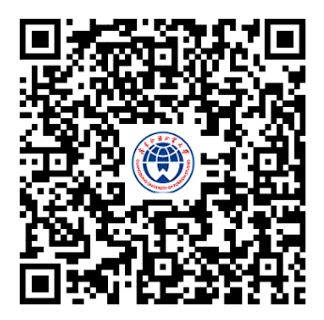
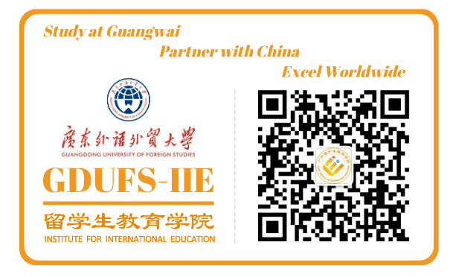
联系电话：0086-20-36207141 / 36207142
官网：https://iie.gdufs.edu.cn/ ，
电子邮件：studyiniie@gdufs.edu.cn
微信官方公众号：GDUFSIIE

Address: Office 102, Mingede No. 7th Academic Building, Guangdong University of Foreign Studies, No. 2nd Baiyun Avenue North, Baiyun District, Guangzhou City, Guangdong Province PR China
(Institute for International Education), Zip code: 510420
Contacts: 0086-20-36207141, 36207142
Website: https://iie.gdufs.edu.cn/,
E-mail: studyiniie@gdufs.edu.cn
Wexin Official Account: GDUFSIIE


广东外语外贸大学 留学生教育学院
2026年9月20日
Institute for International Education, Guangdong University of Foreign Studies
September 20, 2026

附录1. 广东外语外贸大学国际学生学历项目学费一览表
Appendix 1. [GDUFS] List of Tuition Fees of Degree Programs for International Students
附录2. 广东外语外贸大学国际学生·学历生网上报名指南
Appendix 2. [GDUFS] Online Application Guidance for International Degree Students
附录3. 广东外语外贸大学关于来华留学本科入学学业水平测试（CSCA）及其他补充材料的说明
Appendix 3. [GDUFS] Notice on China Scholastic Competency Assessment (CSCA) ＆Other Supplementary Materials

附 录1
Appendix 1

广东外语外贸大学国际学生学历项目学费一览表
[GDUFS] List of Tuition Fees of Degree Programs for International Students
序号  No. | 学历项目  Programs | 金额（元）  Amount (RMB) | 单位  Per
1 | 报名费  Application fee | 500 | 新生入学一次性收取1-time fee charged  for new students
2 | 汉语言本科  Chinese B.A. programs | 20,000 | 年year
3 | 全英授课本科  English-taught undergraduate programs | 33,800 | 年year
4 | 中文授课本科  Chinese-taught undergraduate programs | 20,000 | 年year
5 | 学术型硕士（3年制）  Academic master programs (3-years’ program) | 25,000 | 年year
6 | 国际中文教育硕士（2年制）  (Master of International Chinese Language Education) (2-years’ program) | 28,000 | 年year
7 | 国际商务硕士 MIB（2年制）  MIB (Master of International Business) (2-years’ program) | 28,000 | 年year
8 | 工商管理硕士 MBA（2年全日制）  MBA (Master of Business Administration) (2-years’ full-time program) | 54,000 | 年year
9 | 工商管理硕士 MBA（3年非全日制）  MBA (Master of Business Administration) (3-years’ part-time program) | 36,000 | 年year
10 | 博士研究生（4年制）  Doctorate programs (4-years’ program) | 30,000 | 年year
*备注：报名费已经支付，不予退费。所交学费在学期开始前以正当理由申请，经学院审核通过后可退80%。
如涉及违法违规行为无法继续学习，所有费用不予退还。
* Note: Application fee is not refundable once paid. 80% of the tuition fee could be refunded after the application is approved by the IIE before semester officially starts. All fees will not be refunded if one was unable to continue schooling due to his/ her illegal behaviors or activities.

附 录2
Appendix 2

广东外语外贸大学国际学生·学历生网上报名指南
[GDUFS] Online Application Guidance for International Degree Students

- 登录官方网址: http://iie-en.gdufs.edu.cn/， 点击“网上报名Online Application” 图标。
Login official website: http://iie-en.gdufs.edu.cn/ and click the Online Application button.


- 点击“注册”按钮，创建个人账号。
Click Register button to create your own account.
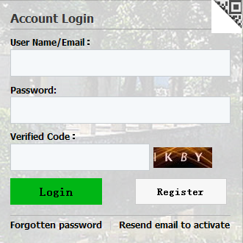

- 填写以下信息，注意必须使用常用的有效邮箱。
Fill in all the information with commonly used valid E-mail!(Important)
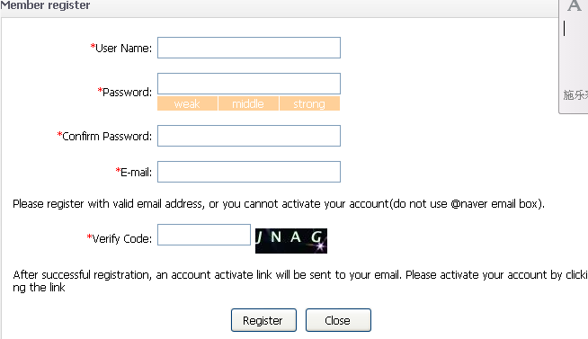

- 查看邮箱并且激活你的账户。
Go check your email and activate the account.
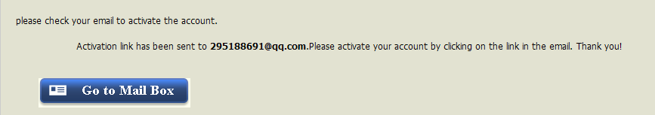
- 点击激活。
Entry for Activation.
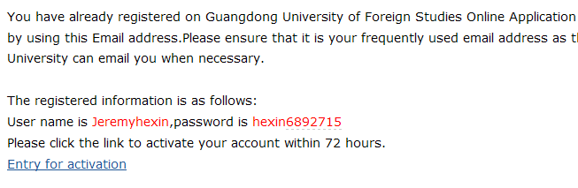

- 选择“个人自费”。
Select Self-Sponsored.


- 选择你要申请的学历项目类别：“本科生”，“硕士研究生”或“博士研究生”。
Select the program category that you want to apply for: Undergraduate Student, Postgraduate Student or Doctoral Student.
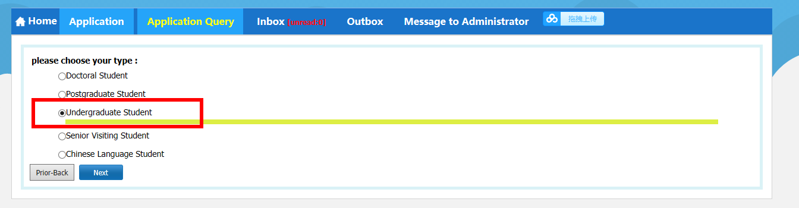

- 选好你要申请的学院及专业后点击“申请”按钮。
Select department and major that you want to apply for then click the Apply button.
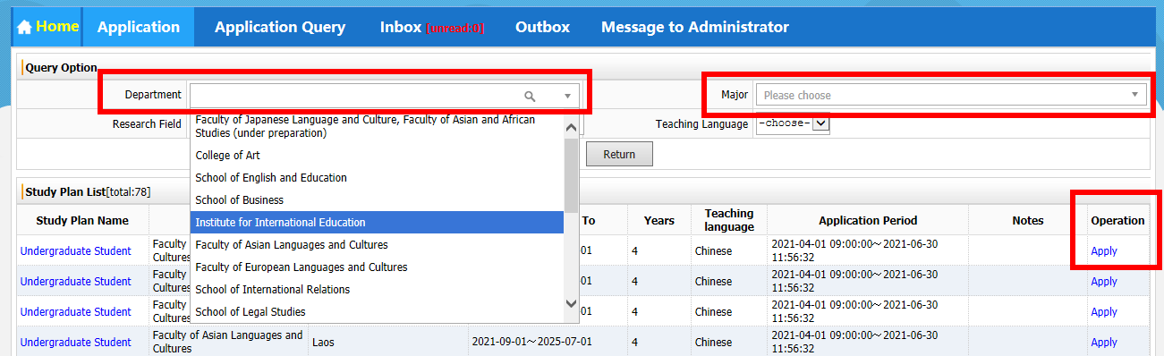

- 填写信息，带红色星号*的为必填。在要求上传个人照片部分，你可以首先上传任意一张电脑储存的照片以完成报名程序。稍后可重新打开网页上传属于你的个人照片。
Fill all the items with red star mark * in the form. As for your personal photo, you can upload a picture stored in the computer to finish the application first. Later you may open the same page and upload your personal photo.
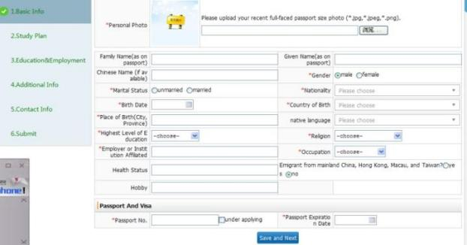
- 一步一步往下填写以及上传相应格式的所需材料
Step by step fill in the form and upload the required documents in the corresponding format.
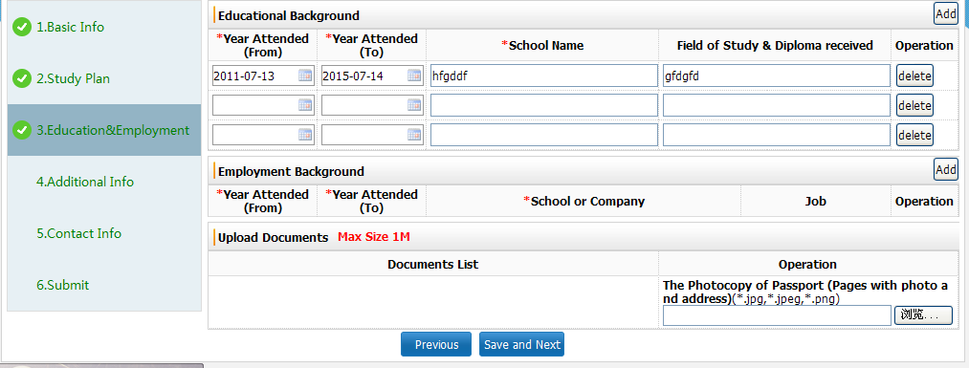

- 填写表格以及上传所需附件，一共6页。
Fill in the form and Upload required attachment. Six pages in all to be filled in.
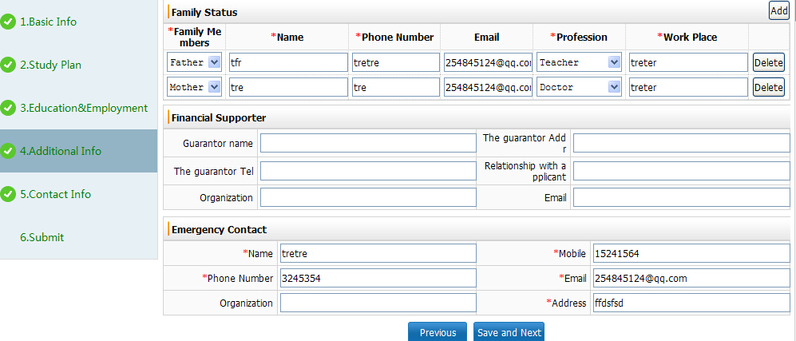

- 填写表格以及上传所需附件，一共6页。
Fill in the form and Upload required attachment. Six pages in all to be filled in.
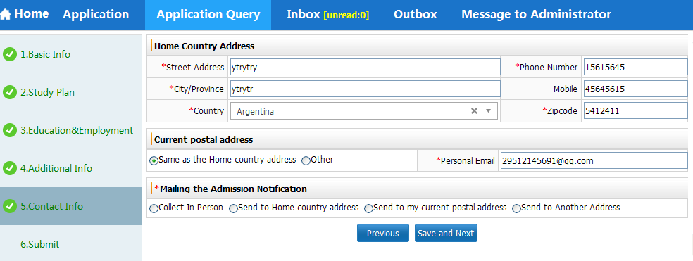

- 点击“提交”按钮，此步骤后将会生成报名编号，报名视为完成。
Click the Submit button. After this step, the application number will be generated and the application is deemed to be completed.
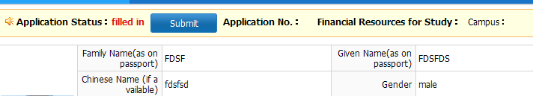

附 录3
Appendix 3

广东外语外贸大学关于来华留学本科入学学业水平测试（CSCA）
及其他补充材料的说明
[GDUFS] Notice on China Scholastic Competency Assessment (CSCA)
＆Other Supplementary Materials

- 申请人及父母国籍证明文件
1. 原为中国大陆（内地）、香港特别行政区、澳门特别行政区和台湾地区居民，后加入外国国籍者，需提交：
（1）户籍注销证明或退出中国国籍证明，或提交中国外交代表机构和领事机关出具的无中国国籍的官方证明文件
（2）加入外国国籍满4年或以上的证明
（3）2022年9月30日起至2026年9月30日出入境记录（以护照上的出境入境章为准）
2.在外国出生即取得外国国籍的申请人，父母双方或一方为中国公民的，需提交：
（1）出生证明或户口本，证明亲属关系
（2）申请人出生即取得外国国籍证明
（3）申请人出生前父母（中国公民方）在外国的永久居留证明
（4）2022年9月30日起至2026年9月30日出入境记录（以护照上的出境入境章为准）
以上文件如原文非中文，须提供中文翻译公证本。
- Nationality documents of the applicants and their parents
**Those who were originally citizens of Chinese Mainland, Hong Kong Special Administrative Region, Macao Special Administrative Region and Taiwan district then have acquired foreign nationalities need to submit:
(1)A certificate of cancellation of household registration or a certificate of renunciation of Chinese nationality, or an official certificate of non-Chinese nationality issued by a Chinese diplomatic representative or consular office.
(2) Proof of naturalization of foreign nationality for at least 4 years or above.
(3) Entry and exit records from September 30, 2022 to September 30, 2026 (based on the entry and exit stamps in applicant’s passport).
** Applicants who acquired foreign nationality at birth and whose parents are both or one of the parents is a Chinese national are required to submit:
(1) Birth certificate or household register to prove kinship
(2) Proof that the applicant has acquired foreign nationality at birth
(3) The permanent residence certificate of the applicant's parents (Chinese citizens) in a foreign country before the birth of the applicant
(4) Entry and exit records from September 30, 2022 to September 30, 2026 (based on the entry and exit stamps in applicant’s passport).
If the above required documents is not in Chinese, a notarized Chinese translation shall be provided.

- 来华留学本科入学学业水平测试（CSCA）成绩
来华留学本科入学学业水平测试（China Scholastic Competency Assessment，简称 CSCA）：自2026/2027学年起，申请在中国政府奖学金院校就读本科学历教育的来华留学生，须在提交申请前参加测试，测试成绩应作为各校审核录取的必要材料之一。 学 校 和 考 生 可 登 录 CSCA 官 方 网 站（www.csca.cn）了解更多信息。2025 年 12 月 21 日将启动 CSCA 考试的全球首考。自2026 年起，形成固定考试周期，每年分 5 次组织考试，时间分别安排在 1 月、3 月、4 月、6 月及 12 月。测试科目包括专业中文、数学、物理、化学4个科目。专业中文提供文科中文和理科中文两类测试。凡申请以中文授课进行本科专业学习的申请人，应根据所申请专业类别，参加相应方向的专业中文测试。申请全英文授课本科学历教育的申请人无需参加专业中文测试;申请攻读汉语言本科专业的申请人如能提供有效期内HSK四级成绩报告，可免考专业中文。基础科目中，无论申请何种专业，数学均为必考科目；此外，申请理、工、农、医类专业者，原则上要求申请人至少选考上述两门科目中的一门。数学、物理、化学均提供中英文试卷,申请人可根据授课语言要求选择试卷语种。
2. China Scholastic Competency Assessment (CSCA): Starting from the academic year 2026/2027, international students applying for undergraduate programs at Chinese government scholarship universities /institutions must take the test before submitting their applications. The test results should be one of the necessary materials for each university/institution to review and admit students. University/institutions and applicants can visit the official website of CSCA (www.csca.cn) for more information. The first global exam of CSCA will be launched on December 21, 2025. From 2026, a fixed examination cycle will be formed, with exams organized five times a year: in January, March, April, June, and December every year. The test subjects include: professional Chinese, mathematics, physics and chemistry. Professional Chinese offers two types of tests: liberal arts Chinese and science Chinese. Applicants applying for undergraduate programs taught in Chinese should take the corresponding direction of professional Chinese test based on the category of the applied major. Applicants applying for English-taught undergraduate programs do not need to take the professional Chinese test; applicants applying for a bachelor's degree in Chinese language can be exempted from the professional Chinese test if they can provide a valid HSK Level 4 score report. In the basic subjects, regardless of the applied major, mathematics is a compulsory subject; in addition, applicants for science, engineering, agriculture, and medicine-related majors are generally required to choose at least one of the above two subjects -- physics or chemistry. The test for mathematics, physics and chemistry are provided in both Chinese and English, and applicants can choose the language of the test according to the teaching language requirements.

三、无犯罪记录证明
申请人须提交由所在地公安机关出具的有效期内的无犯罪记录证明，通常应为提交申请之日前6个月以内的证明文件。要求中文翻译，并必须加盖中国驻该国大使馆的领事认证章或者做海牙认证。此文件须原件提交至我校，扫描件及复印件无效。邮寄原件前请务必先发电子版与学校确认内容是否符合规范，并与学校确认邮寄地址。
3. Non-Criminal Record Certificate
The applicant must submit a Non-Criminal Record Certificate issued by the local public security authorities usually within a 6-months’ validity before the date of submission of the application. The Non-Criminal Records Certificate should be with Chinese language translation and official notarization stamp from the overseas Chinese embassy or consulate, or with the APOSTILLE verification. The certificate must be submitted to the University in original, scanned version or photocopy is invalid. Before sending the original, please be sure to send an electronic version to confirm with the University whether the content meets the requirement, and confirm the mailing address as well.

四、出生证明及监护人保证书的公证件
2026年9月1日前未满18周岁的外籍学生，须提交出生证的公证翻译（中国驻外使领馆的领事认证，或海牙认证；如是海牙认证，认证页也需要翻译成中文）和父母护照复印件，或提供本国驻中国使领馆出具的出生关系证明，需记载父母和学生本人全名；另还须提交监护人保证书及公证件，监护人须为居住在中国境内的成年人。此文件须原件提交至我校，扫描件及复印件无效。邮寄原件前请务必先发电子版与学校确认内容是否符合规范，并与学校确认邮寄地址。*请注意：此证明一经提交，不予退还。
4. Notarized Birth Certificate and Guardian Guarantee Certificate
Anyone under the age of 18 before September 1, 2026 must a notarized translation of their birth certificate (with the consular certification from the overseas Chinese embassy or consulate, , or with the APOSTILLE verification; if it is with the APOSTILLE verification, the verification page also needs to be translated into Chinese) and copies of their parents' passports, or provide a birth relationship certificate issued by the embassy or consulate of their home country in China, which should list the full names of both the parents and the student. Moreover, a notarized guardian guarantee certificate should be submitted as well, which requires the guardian must be an adult living in Chinese Mainland. The certificate must be submitted to the University in original, scanned version or photocopy is invalid. Before sending the original, please be sure to send an electronic version to confirm with the University whether the content meets the requirement, and confirm the mailing address as well. *Please note: Once the certificate is submitted, it will not be returned.

- 出勤证明及转学证明
曾在华学习的申请人，须提供由原就读院校开具的最新学期出勤证明（如无单独的出勤率证明，可在学习证明或转学证明上注明出勤率）以及在读期间成绩单。出勤率及成绩须符合在广州市申请学习居留许可的要求。
- Attendance Certificate and Academic Transcripts
Applicants who have previously studied in China must provide an attendance certificate for the most recent semester issued by their former institution (if a separate attendance certificate is not available, the attendance rate may be noted on a Certificate of Enrollment or a Transfer Certificate) as well as a transcript of their academic performance during their studies. The attendance rate and scores on the academic transcript must meet the requirements for applying for a student residence permit in Guangzhou.

六、其他材料
是否需要提交除上述情形所需材料以外的其他补充材料，以申请人具体的实际情况以及留学生教育学院的通知为准。
6. Other materials
Whether it is necessary to submit other supplementary materials other than those required in the above circumstances shall be subject to the actual situation of the applicant and the notice of the Institute for International Education.

